Unit Tests for Room Entity Class

# TC01 – Test Room.book() method

**Description**: This test evaluates the book method in Room entity class. After executing this method, it should return a new Booking object.

**Pre-conditions**: A new guest and a new credit card should be created before calling this method.

**Post-conditions**:

* A new Booking object should be returned.
* isAvailable() should return false for any arrival dates and stay lengths that clash with the new booking.
* The booking state should be pending.

**Data required**:

* A new guest object
* Arrival date
* Staying length
* Number of occupants
* A new credit card object

**Output**:

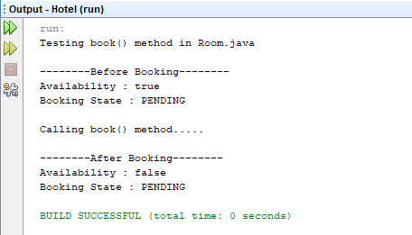

# TC02 – Test Room.checkin() method

**Description**: This test evaluates the basic functionality of the check in method in Room entity class. This method is executed when the booking.checkIn() method is executed. Therefore the correct way to test this method is to execute the booking.checkIn() method.

**Pre-conditions**:

* A room should be booked first.
* The room state should be READY.

**Post-conditions**:

* The room state should be OCCUPIED.
* The booking state should be CHECKED_IN.

**Data required**:

* A new booking with booking status READY

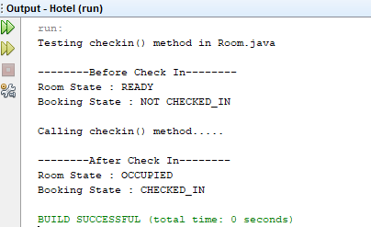**Output**:

# TC03 – Test for Exceptions in Room.checkin() method

**Description**: This test evaluates the checkin method in Room entity class when the state of the room is not READY. The state is changed by executing the checkin method twice.

**Pre-conditions**: A new guest and a new credit card should be created before calling this method.

**Post-conditions**:

* A runtime exception should be thrown stating “Room is not ready”.

**Data required**:

* A booking which is not in READY state.

**Output**:

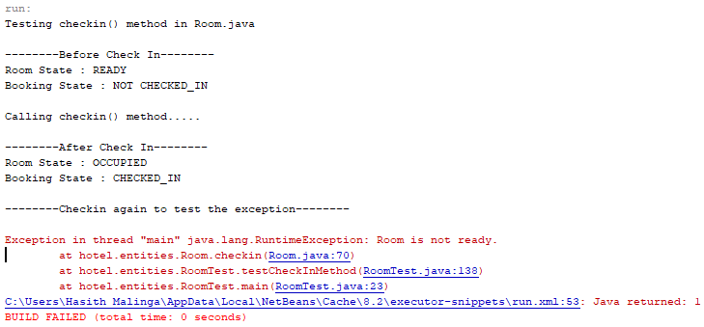

# TC04 – Test Room.checkout() method

**Description**: This test evaluates the basic functionality of the checkout method in Room entity class. This method is executed when the booking.checkOut() method is executed. Therefore, the correct way to test this method is to execute the booking. checkOut() method.

**Pre-conditions**:

* The booking state should be CHECKED_IN.
* The room state should be OCCUPIED.

**Post-conditions**:

* The room state should be READY.
* The booking state should be CHECKED_OUT.

**Data required**:

* A new booking with booking status CHECKED_IN

**Output**:

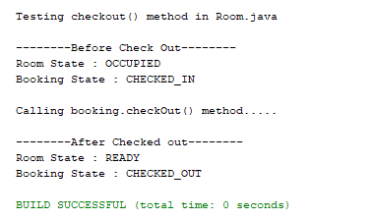

# TC05 – Test for Exceptions in Room.checkout() method

**Description**: This test evaluates the checkout method in Room entity class when the state of the room is not OCCUPIED. This is achieved by executing checkout method twice.

**Pre-conditions**: The room should not be occupied at the time of checking out.

**Post-conditions**:

* A runtime exception should be thrown stating “Room is not occupied”.

**Data required**:

* A booking which has a room which is not in OCCUPIED state.

**Output**:

